Please do these assignments :
- On your page, show alert for the user that say “Welcome to my site”, then show him prompt ask him to enter his name and write to the page “ welcome + his name”. (Remark what happen to the home page after writing welcome page).
- Make a function in external JS file, that takes 2 parameters and return sum of them (function return the result, don't alert or print inside it), and make a button that when clicked; asks the user to enter 2 numbers (prompt), call the sum function, and display the result returned by the function in the console.
- Create a function that takes a number as its only argument and returns true if it's less than or equal to zero, otherwise return false. (use ternary conditional operator).

Examples
lessThanOrEqualToZero(5) ➞ false
lessThanOrEqualToZero(0) ➞ true
lessThanOrEqualToZero(-2) ➞ true

- Make a function that takes Student faculty as a parameter, checks:
  - If the entered faculty: FCI, show message: “'
  - If the entered faculty: Engineering, show message: “You’re eligible to Network and Embedded tracks”.
  - If the entered faculty: Commerce, show message: “You’re eligible to ERP and Social media tracks”.
  - For any other faculty, show message: “You’re eligible to SW fundamentals track”.
(Use switch(). And why it’s better in that case?).
5-Write a function that takes the base and height of a triangle and return its area.
triArea(3, 2) ➞ 3
triArea(7, 4) ➞ 14

Notes
- The area of a triangle is: (base * height) / 2
- Don't forget to return the result.
Bonus Assignments:
- Make function that write “welcome to my page” 6 times using h1 to h6 header sizes using one line (document.write) javascript code “see attached image” . (Use for loop, and don’t use h1 to h6 explicitly).

- Write the previous output (Q.4) on a table and create the table on runtime, like this:
Name | Ahmed
Birth year | 1981
Age | 30
- Work on the mentioned self-study topics on the lecture slides:
  - What’s XSS (cross-site scripting)?
  - What are new features in ES6, with demo?
  - What’s TypeScript? And what are its new features?
- Design a list of skills like the following, and when click (X) of each one it should closed.
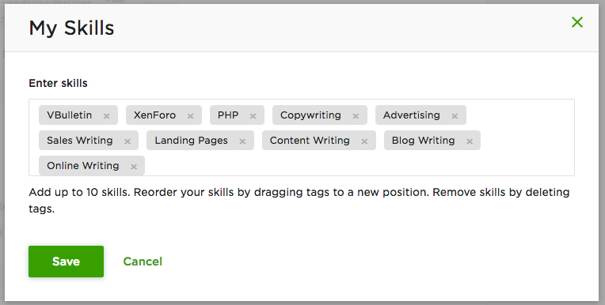
===================================================================
<Script>document.write(“Thank YOU”) </Script>

